Hoisting Nested Functions

Abstract:
With the widespread use of Javascript in web development, performance is a factor of concern which may affect the speed of the browser. One such performance limiting factor is nested functions in JavaScript. In this project we have developed an analysis using Jalangi2 framework and NodeJS to detect the hoist-ability of the nested functions in Javascript. This approach is evaluated on the Javascript Library Lodash, to check the improvement in the performance of Javascript in Google V8 engines.

Introduction:
JavaScript is used for both client side and server side scripting. Among the many features it provides, one of the features that we are interested in is hoisting of function declarations. Hoisting is moving the variables or function declarations to the top of the scope. JavaScript also allows nesting one function inside the other. This is because nesting reduces the global name-space pollution[1]. Also, if a function has to access the local variable of another function then it has to be nested under the function whose variable it wants to access. This helps in maintaining the privacy of data inside the function.

The nested function is created only when the parent(outer) function is invoked. So if the outer function is called in a loop then the nested function gets created on every call no matter if it is used for the computation or not. This would reduce the performance of Javascript engine. So if the nested functions are not dependent on any variables or parameters of the parent function, it is better to hoist the nested functions for better performance.

In this project we are using Jalangi2, a dynamic analysis framework for JavaScript to detect if a function is nested and if it can be hoisted or not. Jalangi2 provides many APIs to check what values are exchanged and how the control flow of the JavaScript file is in the interpreter. We are using functionEnter(), functionExit(), read(), write() and declare().

Nested Functions’ Hoisting Rules:
To hoist a function declaration to another scope, we need to follow these two rules:

Rule 1: The nested(inside) function must not depend on the local variables of the outer(containing) function/s. These variables include both local variables defined in outer function and parameters of outer function.

It makes sense to not to move a function declaration, which is using the parent’s local variable/s, to the outer scope of the parent, when the nested function’s sole purpose is to maintain the data privacy of the parent function. For example, in Listing 1 we cannot hoist “functionChild3()” because it uses the parameter “a” of its parent “functionParent(a)”. Also we cannot hoist “functionChild4()” because it uses the local variable “b” of its parent function which is again “functionParent(a)”.

Rule 2: If the Rule 1 is satisfied, then the nested function definition can be hoist-able. If the function is hoist-able, then there should be no other function definition with the same name as the nested function at the scope where the hoist/able function has to moved.

In Listing 1, nested function “functionChild3()” inside the scope of “functionChild2()” satisfies Rule 1 as it is neither dependent on the local variables nor the parameters of its parent function “functionChild2()”. But we still cannot hoist the nested functionChild3() outside of its immediate parent’s scope because there is already a function with the same definition at that level. Hence, Rule 2 would be violated if functionChild3() is hoisted under “functionParent(a)”. But we can still hoist this function one step above the “functionParent(a)” which would be at the root level since at this level we do not have any function definition conflicts. Therefore, functionChild3() under functionChild2() can be hoisted just not under functionParent().

Listing 1
function functionParent(a) {
var b = 1;
function functionChild3() {
var z = a + " Child3";
}
function functionChild4() {
b = b + " Child4";
}
function functionChild2() {
var x = " Child2";
function functionChild3(){
var y = 8;
return
}
return functionChild3();
}
functionChild4()
functionChild3()
return functionChild2();
}
functionParent(“Hello”);

Algorithm of the analysis:
As mentioned in the Section (Introduction) we are using Jalangi2, a javascript dynamic analysis framework for our project. This framework instruments any given piece of javascript code by attaching its callbacks to it. In this project, we are using following Jalangi2 callbacks:
- functionEnter()
Triggered before starting the execution of a function
- functionExit()
Triggered when the execution of a function is completed
- read()
Triggered after reading a variable
- write()
Triggered before writing a variable
- declare()
Triggered when the scope of a local variable starts

FunctionEnter() and FunctionExit() are the two basic callbacks which define the entry and exit point of our analysis. Moreover, in order to keep track of the nested function hierarchy we are maintaining a simple Tree in which each “node” represents all the information required for a single function to determine its hoistability. Listing 5 shows the data structure of each node:

Listing 2
Node{
Parent //node of parent function
children[] //Array of nodes for children functions
variables[] // Array of variable{name, isArgument}
name //function name
isHoistableWithParent //Boolean flag
nonHoistableParents[] //Array of nodes
}

Figure 1, is a flow chart diagram of the entry point of our anaylsis. So when a function is called, the FunctionEnter()
callback is invoked in which we create a new node for the function being called. After creating the node, the analysis checks whether the “currentNode”, which is the node representing any function called previously, is empty or not. If it is empty then it is assumed that this is the very first function call of the code base under test and hence, the newNode is to be added as the “rootNode” of the analysis tree. On the other hand, if the currentNode is not empty, then the analysis would rightly detect a function nesting and would add the newNode as a child node to the currentNode. In both cases, the currentNode is updated at the end to newNode. Now the currentNode has its “name”, “parent” and “children” all set up.
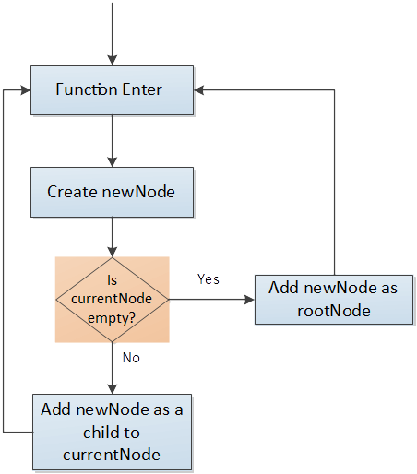
Figure 1

Next read(), write() and declare() callbacks are invoked after the functionEnter() callback finishes. These callbacks are used to check for all the parameters and variables declared or used by the function (currentNode) and then add them to the array of “variables” defined in the currentNode.

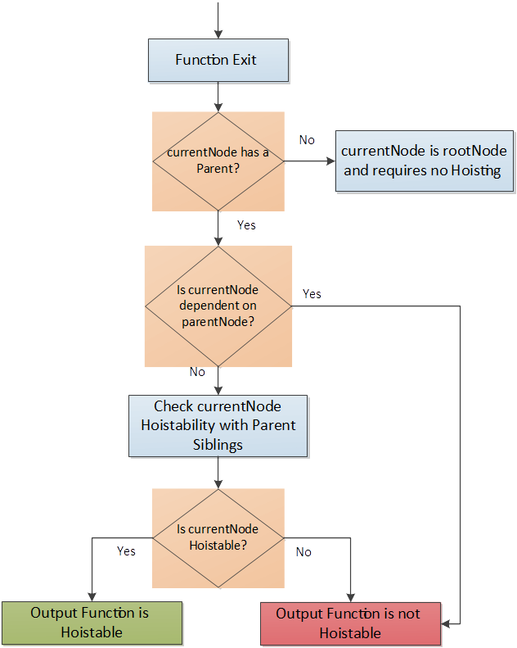
Figure 2

This is how the whole tree structure is built for all the functions by the analysis. Now, when a function represented by currentNode in Figure 2 exits then the functionExit() callback is invoked. In which case the analysis first checks Rule 1 (Refer Section) of hoistability for the function (currentNode). This means that the analysis checks whether currentNode is using any of the variables or parameters defined or used by its parentNode. If yes, then the flag “isHoistableWithParent” is set to false and at the end this function would be displayed as “Not hoistable”. On the other hand, if the function (currentNode) is not dependent on its parent function (parentNode) then this flag “isHoistableWithParent” is set to true.
Now comes the second rule of hoistability which is to make sure that the scope in which the function (currentNode) is to be hoisted does not already have a function definition with the same name. To verify this rule for a given function referred as currentNode in Listing 10 and Figure 2, this analysis recursively traverses through the whole hierarchy above the currentNode and adds all the parents which violate this rule to the list of “nonHoistableParents” of the currentNode. Thus, at the end, the analysis would output exactly under which parent the currentNode would face a definition conflict problem.

Listing 10 shows the pseudocode of the analysis.

Listing 3
functionEnter(functionObject){
TreeNode newNode = new TreeNode(functionObject, currentNode)
if (currentNode == null){
tree.push(newNode)
}
else{
currentNode.addChild(newNode)
}
currentNode = newNode
}

functionExit(){
checkHoistabilityWithParent(currentNode)
if (currentNode != null && currentNode.parent !=null){
currentNode = currentNode.parent
}
else if (currentNode.parent == null){
checkHoistabilityWithParentSiblings(currentNode)
}
}

Completeness of the Approach:

The above mentioned approach works fine for the function declarations. In the below subsections, we are checking the coverage of our approach in different use/corner cases:

1. Function expressions:
When a function definition is assigned to a variable, it is called a function expression. Function assigned to the variable can have a name or they can be “anonymous”, i.e. without a function name.

In case of anonymous functions, our approach stores the function name as anonymous while creating the node. Then we check if the nested function expression is following Rule 1. If it is, then it is hoist-able and can be assigned to another variable in the outer scope.

For example, in Listing 4, where functionTwo() and functionThree() are nested inside functionOne() and functionTwo() respectively. Applying Rule 1, functionTwo() is not hoist-able because it uses the local variables, param, of functionOne(), which is its parent. FunctionThree() is hoist-able because it is not using any local variables of functionTwo().

Listing 4

var one = function functionOne(param) {
var b=1;
var two= function functionTwo(){ //not hoistable
var v = param +1;
var three = function functionThree(){ //hoistable
var c = c + 1;
return c;
}
return three()
}
return two();
}
one(2);

In case of function expressions with a function name, we again check Rule 1 for the nested function expression. If the rule is satisfied, then nested function expression can be hoisted.

For example, in Listing 4, where functionTwo() and functionThree() are nested inside functionOne() and functionTwo() respectively. Applying Rule 1, functionTwo() is not hoist-able because it uses the local variables, param, of functionOne(), which is its parent. FunctionThree() is hoist-able because it is not using any local variables of functionTwo().

Listing 5
var functionOne = function (param) {
var b=1;

var functionTwo = function (){ //not hoistable
var v = param +1;
var FunctionThree = function(){ //hoistable
var c = c + 1
return c
}
return FunctionThree()
}
return functionTwo();
}

functionOne(2);

2. Recursive functions:
While adding child to a node, we compare the name of parent function with the child function name. If the names match and the names are not “anonymous”, then we mark the function as recursive and we do not add this child function.
Consider Listing 6, the function just counts down from the given input. Here if we print the output, it should give us the value 5,4,3,2,1. Function calculateCountdown() is nested inside getCountdown() function and it is not using any local variables of the parent function. So it is hoist-able and our approach gives the correct result.

Listing 6
function getCountdown(countdownValue){
function calculateCountdown(value) { //hoistable
if ( value > 0) {
return calculateCountdown(value-1);
} else {
return value;
}
}
calculateCountdown(countdownValue);
}
getCountdown(5);

3. Direct and Indirect eval()
A program can have function defined inside eval(). Our approach takes care of this case as well. Eval takes the scope where it is invoked. If the eval is invoked inside a function, then it takes the scope of the function under which it is invoked. Our approach applies Rule 1 and Rule 2 check the hoist-ability of this.
In Listing 7, directEval() is in the scope of funcEval(). So it uses the variables x and y of funcEval() and gives the output 8. So directEval() cannot be hoisted according Rule 1.

Listing 7

x = 3;
y = 5;
function funcEval() {
var x = 2;
var y = 4;
eval('function directEval() { return x + y; }'); // Direct call, uses local scope, result is 6
return directEval();
}
funcEval();

When eval is assigned to a variable, it is called indirect eval. The scope of indirect eval() is always global no matter where is it invoked. So the function declared as indirect eval() is always hoist-able if it is nested inside a function.

In Listing 8, though indirectEval() appears to be nested inside funcEval(), it is not. It uses the global variables x and y for calculating return value and returns 8.

Listing 8
x = 3;
y = 5;
var geval = eval;
function funcEval() {
var x = 2;
var y = 4;
geval('function indirectEval() { return x + y; }'); // Indirect call, uses global scope
return indirectEval();
}
funcEval();

In cases where the functions defined inside direct or indirect eval() are nested, our approach successfully handles the hoist-ability detection.

Evaluation:
In order to evaluate the accuracy of the analysis presented in Section (Ref to Approach Section) it was executed on smaller but complicated javascript programs e.g. Listing 1 (mention listings of other examples here). The analysis was able to successfully detect all hoistable functions by checking both Rule-1 and Rule-2.
Next phase of evaluation was focused on detecting any difference in execution time of a code with hoisted functions and without any hoisting. To do this a famous Javascript library Lodash was selected and following steps were followed:
- First the provided test suit of the Lodash library was executed on the original version of the repository multiple times and an average execution time was noted down.
- Then the analysis was executed on the same repository which marked all the hoistable and non hoistable functions.
- Then as per the analysis results, manual hoisting of the repository was performed for 7 detected functions.
- At the end, the Lodash test suit was again executed multiple times but this time on the updated hoisted version of the repository and an average execution time of the test suite was noted down.
Following are the results which were obtained:

Table1
Library | Average Test suit Execution Time
Library | Original Repository | Hoisted Repository
Lodash | 9767 ms | 9704ms

So it can be seen from the results in Table 1, that after only hoisting 7 functions an improvement of around 63ms was observed.
(should we mentioned the false positives reported by our analysis??????????????????????)

Limitations and Future Work:
Our approach has few limitations which can be used for future work. Firstly, while checking recursive functions, we just compare the names of parent function with the child function. If the parent an child have the same name, our approach does not work.

Secondly, our approach tells the levels of nesting of the function. But it does not tell which is the most suitable scope for the function to hoist.

Conclusion:
Nested functions have to be avoided when it does not serve the purpose of abstraction and encapsulation of data. Also nesting functions reduces the performance. So it is better to identify such functions and hoist them. Our approach uses two rules to identify if a function can be hoisted and we are successful in identifying functions which can be hoisted. Also, evaluation of approach on javascript libraries like Lodash showed positive results by showing improvements in runtime

References:
[1] Flanagan. JavaScript: The Definitive Guide. O’Reilly Media, 2011.
[2] https://github.com/Samsung/jalangi2

